**Aim**

To demonstrate virtualization by installing a Type-2 hypervisor (VirtualBox), and creating & configuring a Virtual Machine (VM) with a host operating system (Windows/Linux).

**Algorithm**

1. **Start**
2. Install **Oracle VirtualBox** (Type-2 hypervisor) on the host system.
3. Launch VirtualBox and click on **New VM**.
4. Select the operating system type (Windows/Linux) and version.
5. Allocate system resources (CPU, RAM, storage).
6. Create and configure a virtual hard disk (VDI file).
7. Mount the ISO file of the chosen operating system.
8. Start the VM and proceed with OS installation.
9. Configure network, storage, and guest additions for smooth integration.
10. Verify successful boot and functioning of the guest OS.
11. **End**

**Procedure**

1. **Install VirtualBox**
   * Download Oracle VirtualBox from the official website.
   * Run the installer and complete installation on your host machine.
2. **Create a New Virtual Machine**
   * Open VirtualBox → Click **New** → Enter VM name (e.g., "Ubuntu VM").
   * Choose **Type**: Linux or Windows, and the specific version.
3. **Allocate Resources**
   * Assign **RAM** (recommended 2–4 GB for Linux, 4–8 GB for Windows).
   * Allocate **CPU cores** (e.g., 2 cores for better performance).
4. **Create Virtual Hard Disk**
   * Select **Create a virtual hard disk now**.
   * Choose **VDI (VirtualBox Disk Image)**, Dynamically allocated.
   * Set disk size (20–40 GB).
5. **Mount OS ISO File**
   * In VM Settings → Storage → Attach the downloaded ISO (Linux/Windows).
6. **Start and Install Guest OS**
   * Power on the VM.
   * Follow on-screen instructions to install the chosen OS inside the VM.
7. **Configure Settings**
   * Install **VirtualBox Guest Additions** for better performance (graphics, clipboard sharing, file transfer).
   * Configure networking (NAT/Bridged).
8. **Verify Virtualization**
   * Check if the VM OS boots successfully.
   * Test running applications and host-guest interaction.

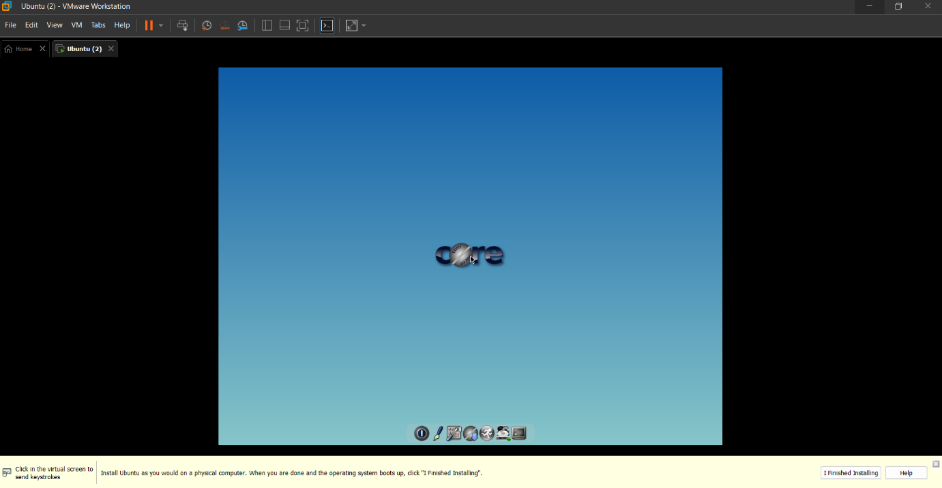

**Result**

A **Virtual Machine (VM)** was successfully created and configured using **VirtualBox (Type-2 Hypervisor)**. The guest operating system (Windows/Linux) runs inside the VM, demonstrating virtualization by allowing multiple OS environments to coexist on a single physical machine.